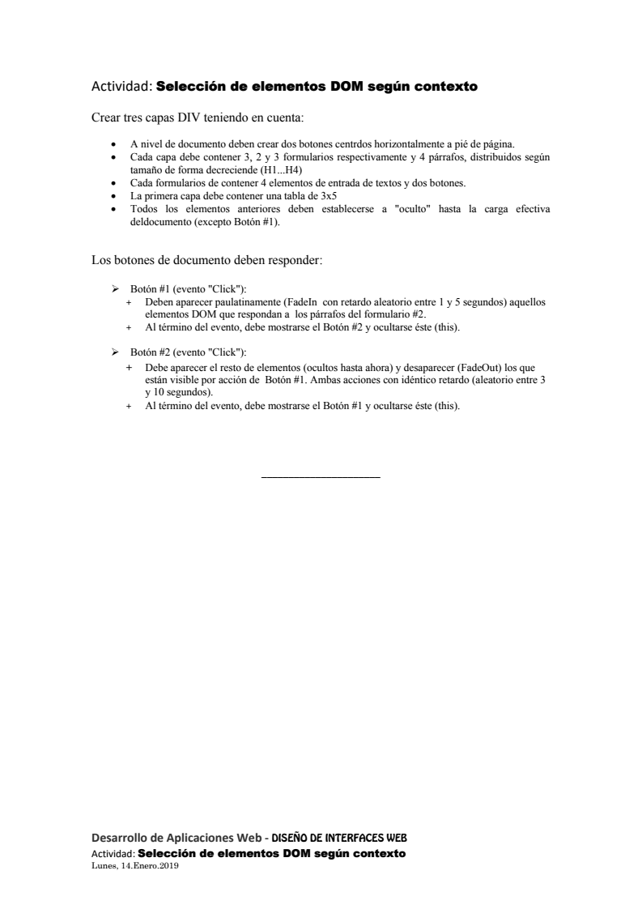

Html:
<!DOCTYPE html>
<html lang="en" dir="ltr">
<head>
<meta charset="utf-8">
<title>Primer script con jQuery</title>
<script src="../JQuery.js" type="text/javascript"></script>
<script src="script.js" charset="utf-8"></script>
<link rel="stylesheet" href="master.css">

</head>
<body>
<div class="">
<table>
<tr>
<th>Company</th>
<th>Contact</th>
<th>Country</th>
</tr>
<tr>
<td>Alfreds Futterkiste</td>
<td>Maria Anders</td>
<td>Germany</td>
</tr>
<tr>
<td>Centro comercial Moctezuma</td>
<td>Francisco Chang</td>
<td>Mexico</td>
</tr>
<tr>
<td>Ernst Handel</td>
<td>Roland Mendel</td>
<td>Austria</td>
</tr>
<tr>
<td>Island Trading</td>
<td>Helen Bennett</td>
<td>UK</td>
</tr>
</table>
<p>
<h1>Parrafo1</h1>
<h2>Parrafo2</h2>
<h3>Parrafo3</h3>
<h4>Parrafo4</h4>
</p>
<form class="" action="#" method="post">
<p>
<label for="text1">Text1: </label>
<input type="text" id="text1" name="" value="">
</p>
<p>
<label for="text2">Text2: </label>
<input type="text" id="text2" name="" value="">
</p>
<p>
<label for="text3">Text3: </label>
<input type="text" id="text3" name="" value="">
</p>
<p>
<label for="text4">Text4: </label>
<input type="text" id="text4" name="" value="">
</p>
<input type="button" name="" value="Boton1">
<input type="button" name="" value="Boton2">
</form>
<form class="" action="#" name="form2" method="post">
<p>
<label for="text1">Text1: </label>
<input type="text" id="text1" name="" value="">
</p>
<p>
<label for="text2">Text2: </label>
<input type="text" id="text2" name="" value="">
</p>
<p>
<label for="text3">Text3: </label>
<input type="text" id="text3" name="" value="">
</p>
<p>
<label for="text4">Text4: </label>
<input type="text" id="text4" name="" value="">
</p>
<input type="button" name="" value="Boton1">
<input type="button" name="" value="Boton2">
</form>
<form class="" action="#" method="post">
<p>
<label for="text1">Text1: </label>
<input type="text" id="text1" name="" value="">
</p>
<p>
<label for="text2">Text2: </label>
<input type="text" id="text2" name="" value="">
</p>
<p>
<label for="text3">Text3: </label>
<input type="text" id="text3" name="" value="">
</p>
<p>
<label for="text4">Text4: </label>
<input type="text" id="text4" name="" value="">
</p>
<input type="button" name="" value="Boton1">
<input type="button" name="" value="Boton2">
</form>
</div>

<div class="">
<p>
<h1>Parrafo1</h1>
<h2>Parrafo2</h2>
<h3>Parrafo3</h3>
<h4>Parrafo4</h4>
</p>
<form class="" action="#" method="post">
<p>
<label for="text1">Text1: </label>
<input type="text" id="text1" name="" value="">
</p>
<p>
<label for="text2">Text2: </label>
<input type="text" id="text2" name="" value="">
</p>
<p>
<label for="text3">Text3: </label>
<input type="text" id="text3" name="" value="">
</p>
<p>
<label for="text4">Text4: </label>
<input type="text" id="text4" name="" value="">
</p>
<input type="button" name="" value="Boton1">
<input type="button" name="" value="Boton2">
</form>
<form class="" name="form2" action="#" method="post">
<p>
<label for="text1">Text1: </label>
<input type="text" id="text1" name="" value="">
</p>
<p>
<label for="text2">Text2: </label>
<input type="text" id="text2" name="" value="">
</p>
<p>
<label for="text3">Text3: </label>
<input type="text" id="text3" name="" value="">
</p>
<p>
<label for="text4">Text4: </label>
<input type="text" id="text4" name="" value="">
</p>
<input type="button" name="" value="Boton1">
<input type="button" name="" value="Boton2">
</form>
</div>

<div class="">
<p>
<h1>Parrafo1</h1>
<h2>Parrafo2</h2>
<h3>Parrafo3</h3>
<h4>Parrafo4</h4>
</p>
<form class="" action="#" method="post">
<p>
<label for="text1">Text1: </label>
<input type="text" id="text1" name="" value="">
</p>
<p>
<label for="text2">Text2: </label>
<input type="text" id="text2" name="" value="">
</p>
<p>
<label for="text3">Text3: </label>
<input type="text" id="text3" name="" value="">
</p>
<p>
<label for="text4">Text4: </label>
<input type="text" id="text4" name="" value="">
</p>
<input type="button" name="" value="Boton1">
<input type="button" name="" value="Boton2">
</form>
<form class="" name="form2" action="#" method="post">
<p>
<label for="text1">Text1: </label>
<input type="text" id="text1" name="" value="">
</p>
<p>
<label for="text2">Text2: </label>
<input type="text" id="text2" name="" value="">
</p>
<p>
<label for="text3">Text3: </label>
<input type="text" id="text3" name="" value="">
</p>
<p>
<label for="text4">Text4: </label>
<input type="text" id="text4" name="" value="">
</p>
<input type="button" name="" value="Boton1">
<input type="button" name="" value="Boton2">
</form>
<form class="" action="#" method="post">
<p>
<label for="text1">Text1: </label>
<input type="text" id="text1" name="" value="">
</p>
<p>
<label for="text2">Text2: </label>
<input type="text" id="text2" name="" value="">
</p>
<p>
<label for="text3">Text3: </label>
<input type="text" id="text3" name="" value="">
</p>
<p>
<label for="text4">Text4: </label>
<input type="text" id="text4" name="" value="">
</p>
<input type="button" name="" value="Boton1">
<input type="button" name="" value="Boton2">
</form>
</div>

<span>
<button type="button" id="boton1" name="button">Boton1</button>
<button type="button" id="boton2" name="button">Boton2</button>
</span>
</body>
</html>

Script:
$(function(){
$('#boton1').click(function(){
var $button = $(this);
var time = (parseInt(Math.random()*5000)+1000);
$($button).fadeOut(time);
$("form[name*='form2']").fadeIn(time, function(){
$('#boton2').show();
});
})
$('#boton2').click(function(){
var $button = $(this);
var time = (parseInt(Math.random()*8000)+3000);
$('*', 'div').fadeIn(time, function(){
$($button).fadeOut(time);
$('#boton1').show();
});
$("form[name*='form2']").fadeOut(time);
});
});

CSS:
table {
font-family: arial, sans-serif;
border-collapse: collapse;
margin: 5px 0px;
}
td, th {
border: 1px solid #dddddd;
text-align: left;
padding: 8px;
}
tr:nth-child(even) {
background-color: #dddddd;
}
div form, table, h1, h2, h3, h4 {
display: none;
}
form {
border: 1px solid black;
display: inline-block;
padding: 5px;
}
span {
text-align: center;
display: block;
bottom: 5px;
position: fixed;
width: 100%;
}
#boton1 {
background-color: blue;
color: white;
}
#boton2 {
display: none;
background-color: red;
}

